English Language Paper 1
Q5: Creative Writing
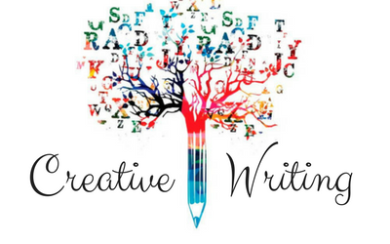
Name: _______________

Teacher: ________________
Mark scheme – turn this into a success criteria of what you might include in order hit these skill descriptors.
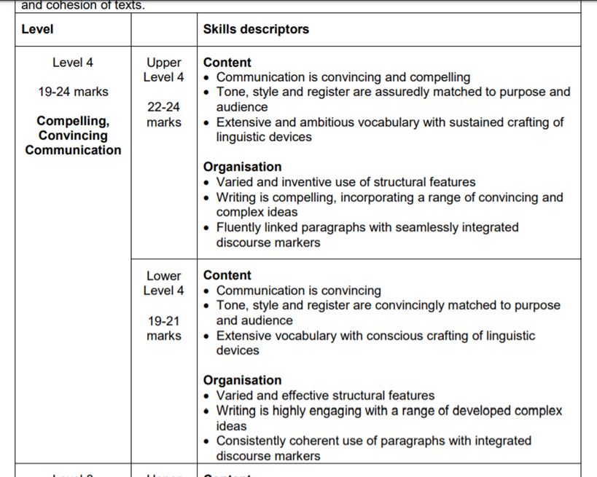
Who am I? Why am I here?
We trudged towards the giant, stone monolith in the middle of the town square. We trudged the same way we always did. At the same time, the same speed and with the same, grim, featureless expression on our faces. We were, I was sure, about to be told of some new victory in some far reaches of the Earth. Of course, most of us had never left Airstrip 1. Most of has had been born here. We grew up here. Most of us would die here.
As our mighty government’s victories echoed around the otherwise quiet square, I could see the stoic yet underlyingly cynical look on the other workers’ faces. Although there was victory, the voice shouted, we had not yet won. Production had to increase in order to provide our troops with necessary resources. Rations would have to be cut. Hours would have to be increased.
It was the same every time. Every victory was a defeat.
We were marched back towards our factories. Our optimism was a thin facade, but one we were forced to maintain.
A thousand cameras followed our every step.
Although they spoke no words, the weapon wielding guards intimidated us with every step we took. They were there to ‘protect us’, we were told. Protect us from what? Our own servility? Our own powerlessness?
They were there to control us.
Who am I? My name is 956898. I am a worker. I have no voice. And when you have no voice, there is no higher power to hear you scream.
Model 1 – look at these examples of top-level responses and annotate them with where they have gained marks. Use the success criteria based on the mark scheme.
Successful things to magpie:

Successful things to magpie:

The darkness encapsulated the light, blanketing any sense of hope, as the grey mass crept across the sky. From above, everything was silent save the water beneath the sky.
The dull blue ferociously slammed against the rocks, brutal and merciless, leaving the rocks with little but a glistening sample of itself. The repetition stabbed the possibility of any light, providing the land with eternal darkness.

The strong smell of salt rebelliously forced itself into every crevice, covering every inch of the air in its thick, heavy scent. The taste of peeling paint led the eye to the distant lighthouse, a star in the gloomy sky. Prominent and tall, the white structure seemed to look down at the wild sea, in disgust and embarrassment, like a parent and a delinquent child.

Disobediently, the sea followed the orders of the wind, and danced erratically to it’s tune, splashing and hurling, spraying and swirling. The wind swept across the sea with the strength and speed that could tear the sky, like a discarded tissue.
The strips of white now wrestled with the dreary abundance of clouds, yearning for the chance to glide across the sky yet the constant dark sheet remained merciless and cold, denying any light through the barriers of gloom.

Model 2 – look at these examples of top-level responses and annotate them with where they have gained marks. Use the success criteria based on the mark scheme.
Successful things to magpie:

He awoke to the sound of curtains being drawn. Like fingernails being scraped down a blackboard, the scratching, screeching sound pierced his being. Reluctantly, he heaved himself out of bed and slowly and heavily went through the motions of preparing for his day.
The daunting prospect of filling 15 hours of daylight swept over him. Shops? Park? Walk?
No plans interested him remotely.
No one to talk to.
No physical or emotional contact to sustain him.
So…should he simply draw the curtain again and retire into the empty darkness? No – that wasn’t the answer. But he was struggling to find the solution that was for sure. Walk then – exercise and fresh air was at least the healthy option!
Dressed and out; passing people and people passing him. He felt invisible and insignificant but thankfully he was able to pause occasionally and peer through the open curtains and observe other’s lives offering him a semblance of connection to humanity.
On he walked through the once comforting streets of his youth where now all he experienced was hostility and rejection. On he walked until he entered the blanket of solitude provided by the wooded parkland. At least here the trees could not reject him! But he was still alone – oh so alone.
Turning back towards ‘home’, he caught a glimpse of his eldest daughter laughing with her friends. Desperately, he tried to catch her eye. Obstinately, she refused to engage…
Back past the warm homes of united families gathering to enjoy their evening meal behind closed curtains. Back past the cold stream of humanity. Back through his front door; trying to ignore the cold shoulder of his wife and younger children.
As usual he ate dinner alone. As usual he undressed alone. As usual he drew the curtains against the dark night – always alone. As usual he was trapped in the dark, stark reality of his own loneliness.
He must have wondered which was the better way to die.
Model 3 – look at these examples of top-level responses and annotate them with where they have gained marks. Use the success criteria based on the mark scheme.

The sun’s blinding glare looked down on me in disgust. Its warm rays dazed my thoughts, confusing my judgement. Longingly I closed my eyes and dreamed of rain. Icy-cold bullets aiming at me from above, punishing my blackened soul. That’s what I deserve! Dismally I opened my eyes to feel the sun still taunting me and tearing away any last hopes of clarity.
A tornado of thoughts whirled around my head and I fought, feebly, to rationalise them. “you did what you had to”, or so I kept telling myself. In a few days I’ll be far away from this hell and I can put this behind me. In the midst of my confusion, I had forgotten my surroundings and realised I stood stiffened on the side of a busy road; hardly acting like nothing had happened as I had ordered myself to.

It was rush-hour and the streets were chaotic. An irregular queue of cars trailed back as far as the eye could see. Multitudes of people passed me all with an individual agenda at the forefront of their minds, unique to their everyday lives, and I couldn’t help but wonder if any of them also had a dark secret. I looked closer at the faces of those passing me and let out a silent scream, my mind was mocking me, and each face was identical to the face of the man I betrayed.
Paralyzed with fear, I blinked vigorously and hoped I would snap into reality. But instead I began to panic. Pounding out of my chest, my heart rate skyrocketed. I could feel the adrenaline race around my body starting at the very tip of my toes and working its way up leaving behind an unpleasant tingling sensation. In the blink of an eye, my breathing had switched from automatic to manual and I found myself panting like a dog. Now shaking, the panic had taken toll over my entire body and I was exhausted from fighting. As the adrenaline finally reached my head and blurred the world around me, I surrendered to the darkness and plummeted backwards onto the side of the road where I remained for what felt to me at the time like an eternity.
Successful things to magpie:

Model 4 – look at these examples of top-level responses and annotate them with where they have gained marks. Use the success criteria based on the mark scheme.

Opening my eyes, I analysed my surroundings carefully I seemed to be in a dimly lit basement of some description. I was accompanied by a piercing sharp pounding in my head and everything around me looked unclear. I couldn’t shake a sinister sense of Déjà vu. The four walls around me felt strangely familiar but every-time I thought I knew why my thought would escape and I’d be back to square one feeling that same strange familiarity.

It wasn’t until I looked at my hands that I fully recognised where I was. I was in a different timescale. Somehow, I was reliving the past. Slowly tilting my head downwards, I saw the gun I was holding. I tried to throw it across to the side of the room, but my thoughts and actions were uncoordinated as though it had been predestined. My trapped thoughts hopelessly attempted to dissuade my soulless body from what was inevitably going to happen. As I my arms rose up and my eyes unwillingly aimed at my innocent victim, who’s pleads fell upon deaf ears, my body prepared itself for the shooting. Gunshots pierced my ears and there lay the lifeless corpse of a decent man whose blood would stain my memory and haunt my dreams for the rest of my life.
Model 5– look at these examples of top-level responses and annotate them with where they have gained marks. Use the success criteria based on the mark scheme.
Successful things to magpie:

Model 5 (continued) – look at these examples of top-level responses and annotate them with where they have gained marks. Use the success criteria based on the mark scheme.
As I let out a sob my body and mind recalibrated and I found myself once more on the pavement at the side of a busy road taunted by a hot summer’s day only now, I was surrounded by people all trying to help me. They wouldn’t help me if they knew what I’d done, I thought to myself. I stumbled to my feet and waited for the dizziness to exit my body before I started to run. I knew what I had to do. The only thing I could do. The only thing I could do that would come anywhere close to justice. And that thing was to turn myself in and spend the rest of my life paying for what I did.

Shimmering, soft light glistens down into the empty space, waves of harmony swimming amongst the darkness. The pockets of darkness are not eerie and petrifying, but instead provide reassurance and tranquillity; the warming touch of a friend or loved one. Cautiously, the gnarled trees stretch towards the all-encompassing light. They are guests in this land. No man nor creature can disrupt the natural order that has been established by the luminous beings that remain watchful, waiting, wary of what could be. A faint hum rings through the air, a melodic lullaby that lures the citizens of the realm into a peaceful slumber, settling them like a mother does her new-born babe.

Successful things to magpie:

Model 6 – look at these examples of top-level responses and annotate them with where they have gained marks. Use the success criteria based on the mark scheme.
Malicious. Relentless. Merciless.
Tragically, the furious winds pierced everyone, before disappearing again- invisible. An army of clouds gathered in the sky, blocking out all sunlight and all hope, and casting an ominous shadow on the ground, making the snow seem black. The clouds were almost at bursting point: a fresh round of snowfall was imminent.
The storm began. The clouds began to hiss and spit like a savage cat, and the snow fell thick and fast. In the whipping wind, each flake took an unpredictable path, but they all ended up forming one thick blanket. It was as if the day itself was suffocating- as if it was drowning in a sense of dread.
Icy cold gusts of wind knocked the dark, grey, malevolent clouds across the sky; sudden successive flights of bullet fired from within the unrestrained clouds. A weak, pale yellow sun struggles in vain to penetrate the bank of clouds; it was no use. The cold and the dark won that battle…
Tragically, the furious winds exploded comfortably. However, the storm disappeared again. Invisible. Worried about the silence. Where did the storm retreat to? Preparing to pounce? Preparing for its impending merciless ambush?
Strange, it is a huge nothing that we fear after all.

Successful things to magpie:

Model 7/8– look at these examples of top-level responses and annotate them with where they have gained marks. Use the success criteria based on the mark scheme.
Successful things to magpie:

Dawn attacks the woodlands in shivering ranks of grey. Mist loiters menacingly on the marshy ground, rising slowly, like a predator, to encompass the flowers, the grass, the foliage – no life can prevail. Standing to attention like soldiers on the parade ground, the trees lurk menacingly providing a dark and dreary canopy for the weather to carry out its blitzkrieg. Snaking forward, the stream cuts through the forest floor; it overpowers the lifeless stems of the poppies, leaving them bent double. Autumn has completed its invasion. The mouldy, musty carpet of crimson red petals is all that remains, a faint echo of a happier, more peaceful time.

It seemed December still possessed his garden. The ground was hard as iron, the skirts of the dark cypress moved on the chill wind with a mournful rustle and there were no green shoots on the roses as if, this year, they would not bloom. And not on light in any of the windows, only, in the topmost attic, the faintest smear of radiance on a pane, the thin ghost of a light on the verge of extinction.

Planning your own text – Use this structure to help plan the main areas of your writing out

Anaphora (repeated word or phrase) to end to the work.
He realised then that there would be no surprise arrival. No future hope. No enjoyment to feel.

Nothing.
Come back to the beginning and the first thing you described – how has it changed?

Cyclical Structure

Flashback – to show how things have changed
“There was once a time when…”
“Time hadn’t been kind to this…it had…”
“it would be foolish to believe that this was the common state of life here…”
‘Shift’- move that idea on, what has caused it? What effect does it have on another aspect of the scene?

Move that idea on, what has caused it? What effect does it have on another aspect of the scene?

Zoom in on something very specific and the impact that your initial idea has had on this.
As the tranquil waters sat still, the man could see a droplet of water diving through the soft air and into the lake, quietly disturbing the calmness of the scene, the microscopic waves as they expand along the lake.
Establish the mood/tone you want to create

‘Drop’ the examiner by launching them into the action and creating questions to spark their curiosity.
I thought it must have been a lie, or some sort of prank to get my hopes up. I never thought they’d actually work.
Establish the mood/tone you want to create

‘Drop’ the examiner by launching them into the action and creating questions to spark their curiosity.
I thought it must have been a lie, or some sort of prank to get my hopes up. I never thought they’d actually work.
Planning your own texts – Use this structure to help plan the main areas of your writing out
Move that idea on, what has caused it? What effect does it have on another aspect of the scene?

Zoom in on something very specific and the impact that your initial idea has had on this.
As the tranquil waters sat still, the man could see a droplet of water diving through the soft air and into the lake, quietly disturbing the calmness of the scene, the microscopic waves as they expand along the lake.
Move that idea on, what has caused it? What effect does it have on another aspect of the scene?

Flashback – to show how things have changed
“There was once a time when…”
“Time hadn’t been kind to this…it had…”
“it would be foolish to believe that this was the common state of life here…”
Come back to the beginning and the first thing you described – how has it changed?

Anaphora (repeated word or phrase) to end to the work.
He realised then that there would be no surprise arrival. No future hope. No enjoyment to feel.

Nothing.
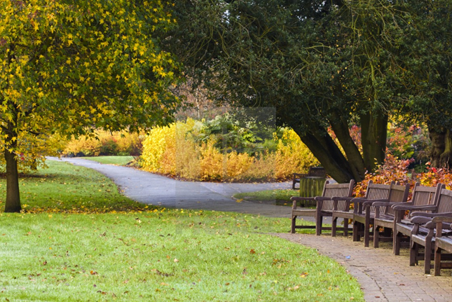
Anaphora (repeated word or phrase) to end to the work.
He realised then that there would be no surprise arrival. No future hope. No enjoyment to feel.

Nothing.
Come back to the beginning and the first thing you described – how has it changed?

Flashback – to show how things have changed
“There was once a time when…”
“Time hadn’t been kind to this…it had…”
“it would be foolish to believe that this was the common state of life here…”
Move that idea on, what has caused it? What effect does it have on another aspect of the scene?

Zoom in on something very specific and the impact that your initial idea has had on this.
As the tranquil waters sat still, the man could see a droplet of water diving through the soft air and into the lake, quietly disturbing the calmness of the scene, the microscopic waves as they expand along the lake.
Move that idea on, what has caused it? What effect does it have on another aspect of the scene?

Planning your own texts – Use this structure to help plan the main areas of your writing out
‘Hook’ your reader by launching them into the action and creating questions to spark their curiosity.
I thought it must have been a lie, or some sort of prank to get my hopes up. I never thought they’d actually work.
Establish the mood/tone you want to create

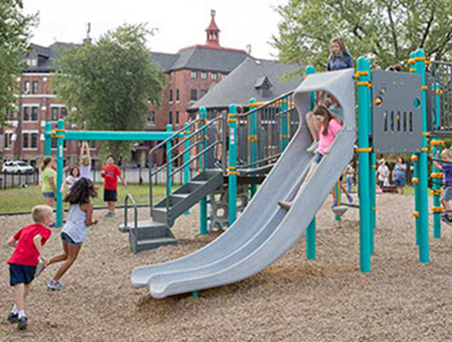
Anaphora (repeated word or phrase) to end to the work.
He realised then that there would be no surprise arrival. No future hope. No enjoyment to feel.

Nothing.
Come back to the beginning and the first thing you described – how has it changed?

Flashback – to show how things have changed
“There was once a time when…”
“Time hadn’t been kind to this…it had…”
“it would be foolish to believe that this was the common state of life here…”
Move that idea on, what has caused it? What effect does it have on another aspect of the scene?

Zoom in on something very specific and the impact that your initial idea has had on this.
As the tranquil waters sat still, the man could see a droplet of water diving through the soft air and into the lake, quietly disturbing the calmness of the scene, the microscopic waves as they expand along the lake.
Move that idea on, what has caused it? What effect does it have on another aspect of the scene?

Planning your own texts – Use this structure to help plan the main areas of your writing out
‘Hook’ your reader by launching them into the action and creating questions to spark their curiosity.
I thought it must have been a lie, or some sort of prank to get my hopes up. I never thought they’d actually work.
Establish the mood/tone you want to create

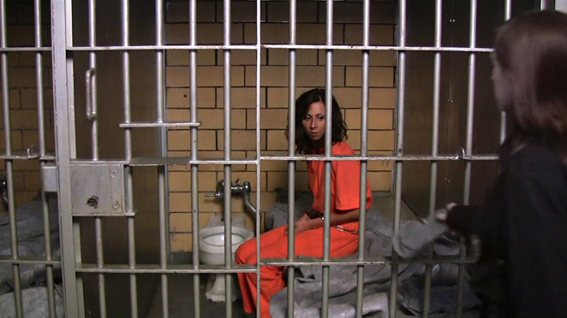
Upgrading your sentence type – use the models to create your own types of sentences in order to add depth to your ideas
Not only but also:
Not only were the boy’s eyes transfixed on the ground, but his face was also covered in a mixture of mud and grease.
Adverb start:
Self-consciously, the boy attempted a smile as passers-by commented on his filthy appearance.
Brackets, although:
The boy’s face was littered with elements of dirt and grease (although it wasn’t as if he wasn’t trying to keep clean) as he wiped the back of his hand over his forehead.
So, so, so:
The boy’s face was so dirty, so filthy, his hair so long and matted, that it wasn’t until he turned his head that I realised he was a boy.
It wasn’t/it was:
The filth wasn’t your ordinary, everyday dirt, but rather it was layers of deep grim, accumulated over years of poverty and deprivation.
Triple noun colon:
Dirt, oil and grease: the boy’s face was smeared with remnants of his day of toil.
Double adjective start:
Abject and alone, the boy peered into the distance, desperately searching for aid.
Simile start:
Like an urban fox, the filthy boy rummaged desperately through the mountain of rubbish.
Simple sentence: The boy looked dirty
Upgrading your sentence type – use the models to create your own types of sentences in order to add depth to your ideas
Not only but also:

Adverb start:

So, so, so:

Brackets, although:

It wasn’t/it was:

Double adjective start:

Simile start:

Triple noun colon:

Simple sentence: The room was bright
Upgrading your sentence type – use the models to create your own types of sentences in order to add depth to your ideas
Not only but also:

Adverb start:

So, so, so:

Brackets, although:

It wasn’t/it was:

Double adjective start:

Simile start:

Triple noun colon:

Simple sentence: The street was windy
Word choice – upgrade the sentences with more ambitious vocabulary and then complete some of your own
__________ ran his ________ fingers ________ though his _________ hair.

Word Bank:
- Aberration: breaking of something that should be your right

- Abhor/Abhorrent: To regard something with horror or hatred

- Ambivalent: Having mixed feelings towards something

- Arcane: mysterious or secret

- Archaic: very old

- Brazen: bold and without shame

- Brusque: Abrupt and informal

- Cajole: To persuade through flattery

- Callous: Insensitive and unfeeling
Word choice – upgrade the sentences with more ambitious vocabulary and then complete some of your own
Word Bank:
- Candour: honesty

- Chide: blame someone

- Circumspect: Careful or cautious

- Clandestine: secretive and hiding something

- Coerce: to compel or force someone

- Coherent: logically connected

- Demure: modest or shy

- Deride: to ridicule or laugh at

- Diligent: hard working

- Embezzle: to steal

- Enmity: deep hatred

The smell of __________ emanated from his _________ jacket, in a kind of haze that _____________ around him.

Word choice – upgrade the sentences with more ambitious vocabulary and then complete some of your own
Word Bank:
- Feral: wild or savage

- Forsake: give up or forget

- Impertinent: rude or disrespectful

- Incisive: direct/powerful

- Inept: clumsy or useless

- Insatiable: impossible to satisfy

- Intrepid: fearless

- Lurid: causing horror or shock

- Morose: being sad or gloomy

- Myriad: many

- Plethora: in great number

- Umbrage: To take offence

- Zenith: highest point

, and : the landscape was with .

Semantic fields – Link your vocabulary in order to set the scene

Making something seem bright:
- Vibrant
- Dazzling
- Luminous
- Beaming
- Glittering
- Scintillating
Making something seem poisonous:

- Venom
- Coursing (flowing)
- Toxic
- Invading
- Contaminating
- Malignant
- Virus

Semantic fields – Link your vocabulary in order to set the scene
Making something seem dark:

- Dank
- Decrepit
- Caliginous
- Obscure

Making something seem busy:
- Tumultuous
- Compact
- Smothering
- Carnage
- Mayhem

Crafting language devices – Take the key word of the language device and craft an extension to it. Think of the cause and effect of that idea in order to continue the idea on
Ideas to extend it:
Attacked
Ranks
Scorched
No pity
Powerlessness
Victim
Predator
Prey
Attrition
Time was the enemy

Ideas to extend it:
Metallic
Roars
Packs hunting
Undergrowth
Dense
Opaque
The once vibrant city had become a concrete jungle.

Crafting language devices – Take the key word of the language device and craft an extension to it. Think of the cause and effect of that idea in order to continue the idea on
Darkness settled over the park

The strong smell of salt rebelliously forced itself into every crevice

Ideas to extend it:
- Blanket
- Smothering
- Claustrophobic
- Stifling
- Suppressing
- Quashing
Ideas to extend it:
- Scent
- Invading
- Morsel
- Fragment
- Particles
- Fighting
- Wrestling
- Assaulting
Crafting language devices – Take the key word of the language device and craft an extension to it. Think of the cause and effect of that idea in order to continue the idea on
Haunting memories had seared themselves into the very fibre of his being.

Ideas to extend it:
- Burning
- Scarring
- Branding
- Tainting
A putrid, pungent odour hit my like a wave.

Ideas to extend it:
- Intoxicating
- Tsunami
- Ripple
- Drowning
- Flooding
- Current
- Waded
Sentence structures – Use these different pieces of punctuation and sentences structures accurately.

Sentence structures:

Fronted adverbial
Quietly, a solitary snowflake settled on the rose in his hand.

Embedded subordinated clause
Heavy clouds, grey tendrils across the sky, searched to extinguish any last vestige of light.

Anaphora
Every town has its heart. Every town has a pinpoint of life and community, and in this small town the market place was exactly that.

Starting with a simile
Like stone gargoyles, the guards stood watch. Silently they stood to attention, never wavering in their loyalty.

Colon to introduce/expand an idea
Her face was drawn and creased with worry: it was slightly wrinkled, skin just starting to sag around lips that were pressed tightly together, yet stretched unnaturally over sharp cheekbones and jaw.

Dash to add extra information
It left a tiny drop of water that possessed an iridescent sheen – equally fragile and equally beautiful as the snowflake it replaced.
Sentence structures – Use these different pieces of punctuation and sentences structures accurately.
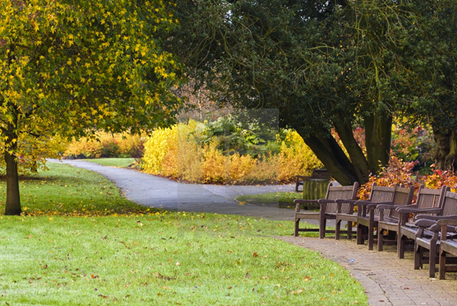
Sentence structures:

Fronted adverbial
Quietly, a solitary snowflake settled on the rose in his hand.

Embedded subordinated clause
Heavy clouds, grey tendrils across the sky, searched to extinguish any last vestige of light.

Anaphora
Every town has its heart. Every town has a pinpoint of life and community, and in this small town the market place was exactly that.

Starting with a simile
Like stone gargoyles, the guards stood watch. Silently they stood to attention, never wavering in their loyalty.

Colon to introduce/expand an idea
Her face was drawn and creased with worry: it was slightly wrinkled, skin just starting to sag around lips that were pressed tightly together, yet stretched unnaturally over sharp cheekbones and jaw.

Dash to add extra information
It left a tiny drop of water that possessed an iridescent sheen – equally fragile and equally beautiful as the snowflake it replaced.
Sentence structures – Use these different pieces of punctuation and sentences structures accurately.
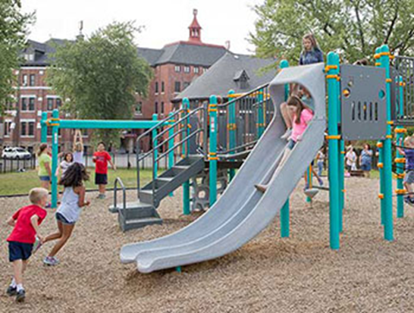
Sentence structures:

Fronted adverbial
Quietly, a solitary snowflake settled on the rose in his hand.

Embedded subordinated clause
Heavy clouds, grey tendrils across the sky, searched to extinguish any last vestige of light.

Anaphora
Every town has its heart. Every town has a pinpoint of life and community, and in this small town the market place was exactly that.

Starting with a simile
Like stone gargoyles, the guards stood watch. Silently they stood to attention, never wavering in their loyalty.

Colon to introduce/expand an idea
Her face was drawn and creased with worry: it was slightly wrinkled, skin just starting to sag around lips that were pressed tightly together, yet stretched unnaturally over sharp cheekbones and jaw.

Dash to add extra information
It left a tiny drop of water that possessed an iridescent sheen – equally fragile and equally beautiful as the snowflake it replaced.
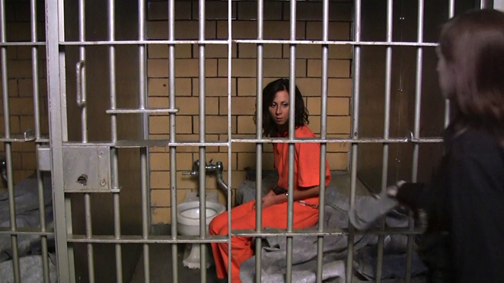
Sentence structures – Use these different pieces of punctuation and sentences structures accurately.
Sentence structures:

Fronted adverbial
Quietly, a solitary snowflake settled on the rose in his hand.

Embedded subordinated clause
Heavy clouds, grey tendrils across the sky, searched to extinguish any last vestige of light.

Anaphora
Every town has its heart. Every town has a pinpoint of life and community, and in this small town the market place was exactly that.

Starting with a simile
Like stone gargoyles, the guards stood watch. Silently they stood to attention, never wavering in their loyalty.

Colon to introduce/expand an idea
Her face was drawn and creased with worry: it was slightly wrinkled, skin just starting to sag around lips that were pressed tightly together, yet stretched unnaturally over sharp cheekbones and jaw.

Dash to add extra information
It left a tiny drop of water that possessed an iridescent sheen – equally fragile and equally beautiful as the snowflake it replaced.

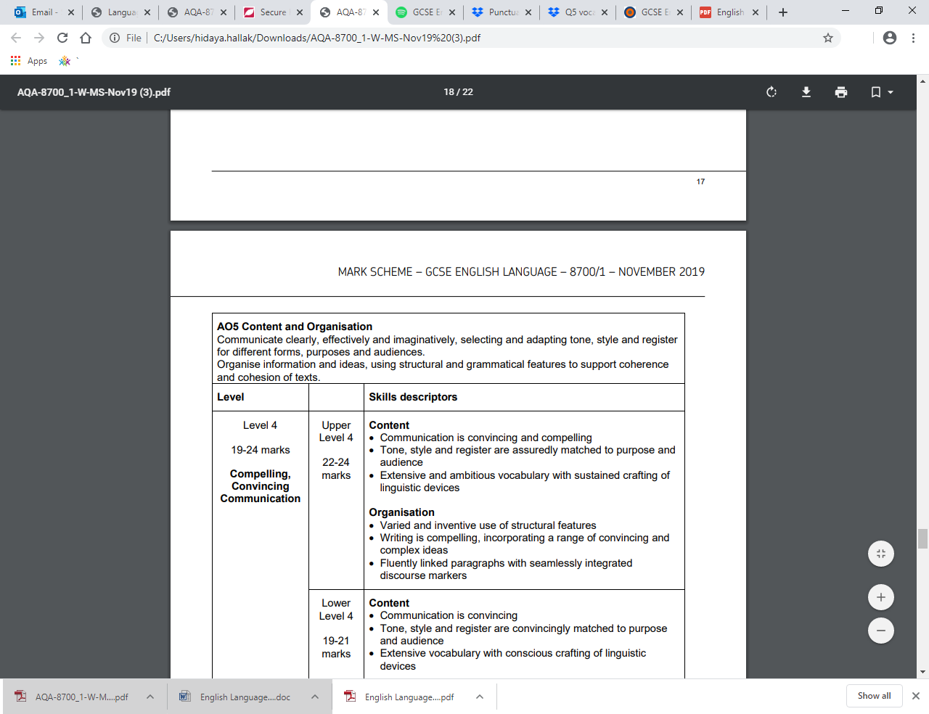

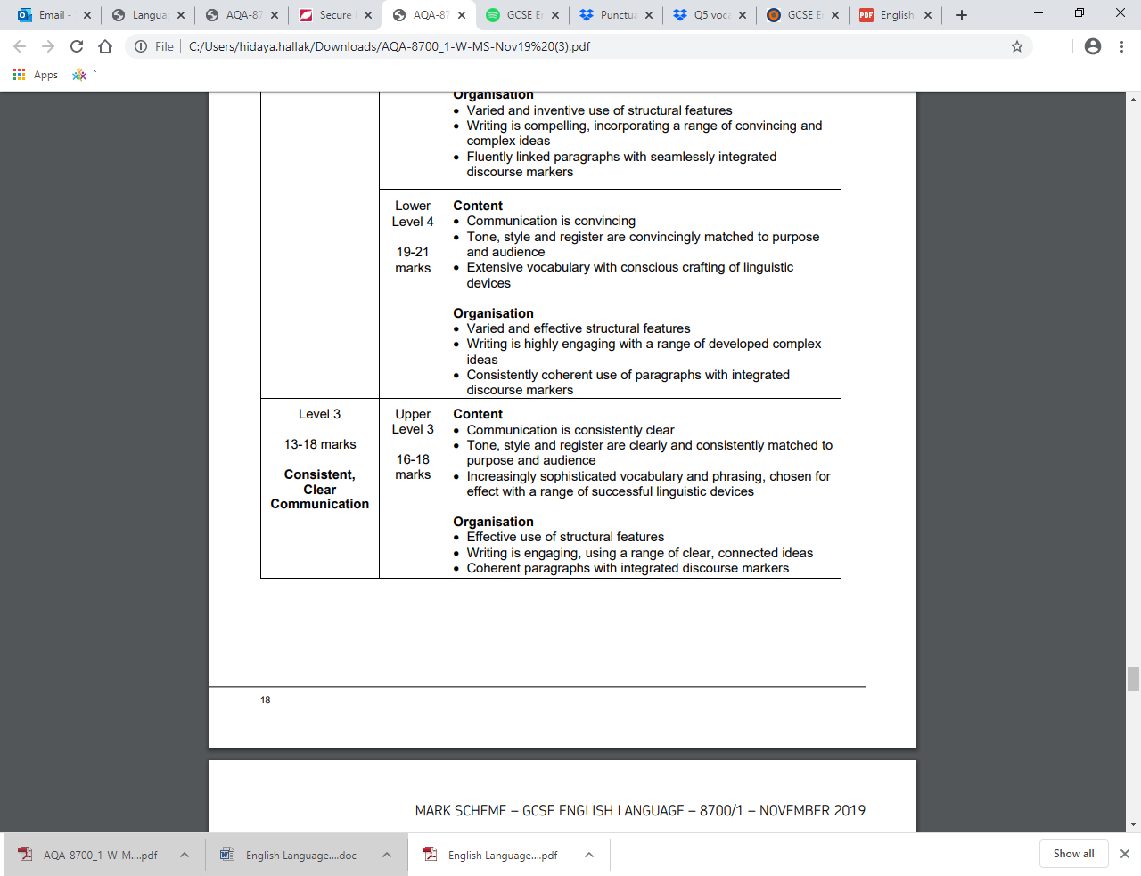

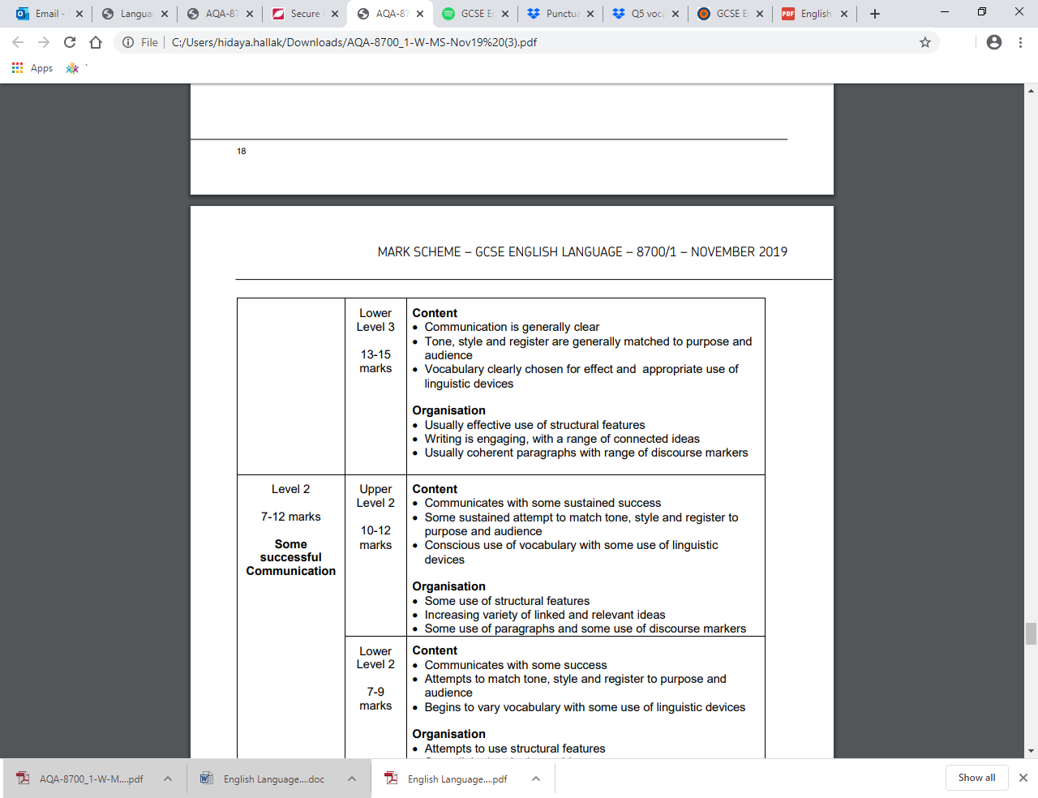

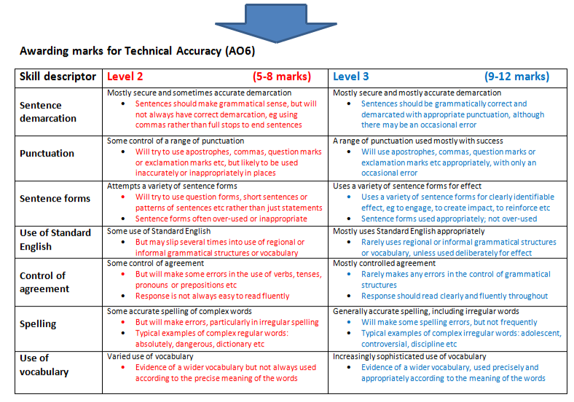
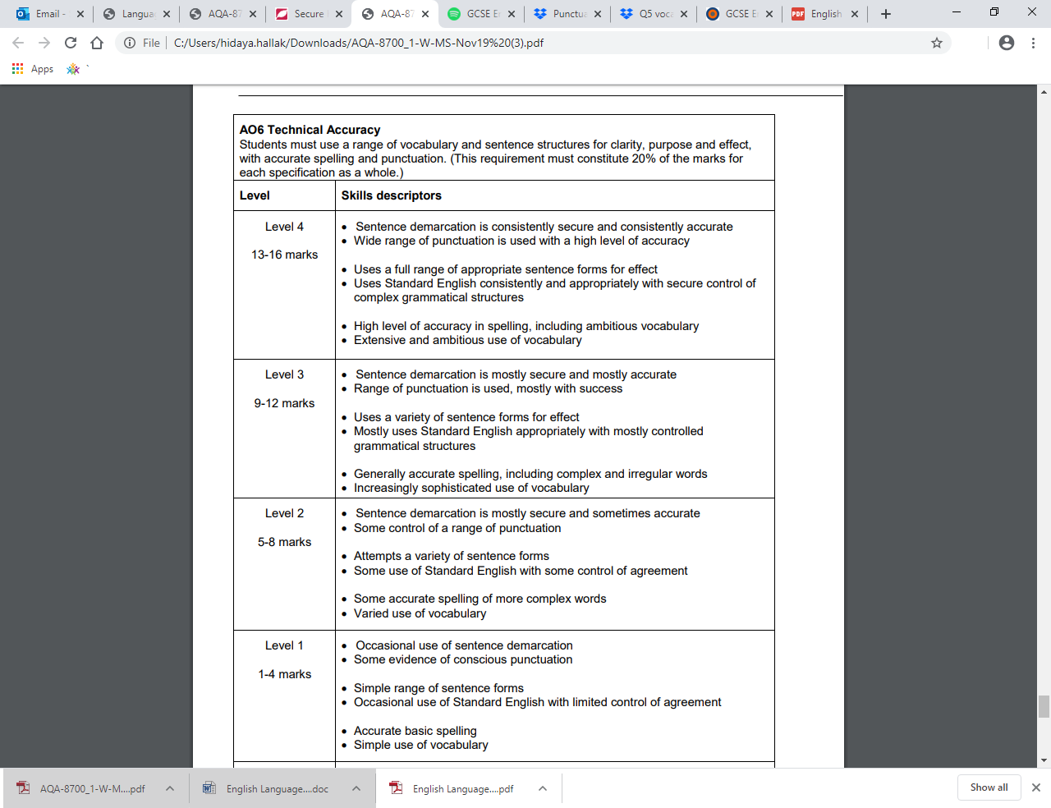

Ideas for varying your sentence openings:

- Use an adverb:

Unsteadily, the lanky, unkempt fellow slinked down the alleyway...

- Use an ‘-ed’ adjective:
Terrified, the girl darted out of the path of her pursuer...

- Use a verb ending in ‘-ing’:

Ambling along the canal tow path, the intoxicated thief spied his victim...

- Use a complex sentence starting with a subordinate
clause:

- Use repeated structures:

Bored of lessons, tired of teachers, and weary of writing, he ran for freedom.

From the sea in the east, to the river in the west, Amy could see for miles.

- Use a simile:
As quiet as a mouse, the girl snuck into her bedroom.
Like diamonds, the stars shone brightly in the sky.
- Use a preposition:

Inside the cave slept a fearful mouse. Under the sea lived a monstrous creature

Although it was still only morning, the sun was already hot. Despite his best efforts, it was clear that the gymnast would never win gold.

Punctuation guide

1. What is a ‘complete sentence’?

To understand what makes a sentence complete, you need to know some terminology.

Subject: the subject of a sentence is the agent—the person who or thing which does the action.
- Eg. ‘car’ in the sentence the car drove faster, or ‘thought’ in the thought of it drove me mad.
Verb: a being or doing word.
- Eg. ‘drove’ in the car drove faster, or ‘was’ in I was tired.
Clause: A group of words that contain a subject and verb. There are two types:
- An independent clause, or main clause, can stand on its own as a full sentence. It has a subject and a verb (these are the necessary ingredients of a full sentence). Two independent clauses can be joined together with a coordinating conjunction, or with a semi-colon.
  - Eg. Offred is the narrator.
  - Some coordinating conjunctions: for, and, nor, but, or, yet, so
- A dependent clause (also called a subordinate clause, or embedded clause), cannot stand on its own, but needs to be attached to an independent clause to form a sentence. Subordinate clauses begin with a subordinating conjunction.
  - whilst Offred does not match the actual criteria to be regarded as a typical rebel
  - even though women who were talented and intelligent were looked down upon
  - because Offred displays this in her actions
  - Some subordinating conjunctions: after, before, if, while, because, although, even though, wherever, whether, since, whereas, unless…
Examples of complete sentences:

- Amir is from Afghanistan. (Simple sentence = one independent clause)
- Amir is from Afghanistan but he moves to San Francisco. (Compound sentence: two independent clauses joined with a coordinating conjunction)
- Amir becomes a writer in the US after fleeing communist rule in Afghanistan. (Complex sentence; independent clause followed by a subordinate clause.)
- After fleeing communist rule in Afghanistan, Amir becomes a writer in the US. (Complex sentence; subordinate clause followed by an independent clause.)

2. What is a comma splice and how can you avoid it?

Comma splices are a form of run-on sentence, a ‘sentence’ that is actually made up of more than one complete sentence and so ‘runs on’ when it should have full stop partway through. It’s called a comma splice when it has a comma instead of a full stop (and this is incorrect).

Eg. We work 9 hours a day, I desperately just need a break.

A sentence is complete if it has a subject (the person or thing ‘doing’ the verb), and a verb (a doing or being word, like ‘runs’, or ‘is’), and makes sense on its own.

In the example above, ‘We’ and ‘work’ are the subject and verb, but so are ‘I’ and ‘need’, and each part would make sense on its own—so we have two complete sentences.

There are three main ways to fix it:

- Full stop: Turn it into two sentences: We work 9 hours a day. I desperately need a break.
- Semi-colon: One main function of the semi-colon is to connect complete sentences: We work 9 hours a day; I desperately need a break.
- Conjunction (usually a coordinating conjunction, but sometimes a subordinating conjunction can be used here if it makes sense.): We work 9 hours a day and I desperately need a break.
  - Be careful: ‘However’ is not a conjunction and so cannot be used here.
- We worked 5 hours, however I’m already tired.
- We worked 5 hours; however, I’m already tired. (Or use a full stop instead of a semi-colon)

3. When should you use a comma, then?

Listing
- When you list several things in a sentence, use a comma after each one e.g ‘I bought apples, bananas, and ice cream.’
- Note: The comma before the ‘and’ (or ‘but’, or ‘or’) is optional. It’s called an ‘Oxford comma’ and some people prefer to use it, others to leave it out. It’s up to you, but best to be consistent.

After a subordinate/dependent clause when it begins a sentence
- Independent (or main) clauses are groups of words that make a full sentence on their own. Dependent, or subordinate, clauses cannot stand on their own but must be attached to a main clause.
- When a dependent clause comes first in the sentence, a comma is required before the independent clause (this sentence is an example).
- Before going to bed, I watered the plants. vs. I watered the plants before going to bed.
- Because he was late, he had to go to reception. vs. He had to go to reception because he was late.
- If you begin with a dependent clause, you need to use a comma.

To separate an appositive or conjunctive adverb
- When a sentence contains non-essential extra information about a noun, or an adverb that relates ideas to one another (conjunctive adverb), these are separated from the rest of the sentence by commas. The commas function a bit like brackets (parentheses)—if you took out the words enclosed by commas the sentence would still make sense.

Appositives:
- Amir, the protagonist of Hosseini’s The Kite Runner, betrays his friend Hassan.
- I gave the book to Sam, that Year 7 student I told you about.
- Note: If the extra information cannot replace the noun, don’t use commas: The man with the yellow hat took care of Curious George. (In this case, ‘with the yellow hat’ is not an appositive.)
Conjunctive adverbs:
- Finally, we got to the top of the hill.
- This, however, is a different situation.
- You know, therefore, what you need to do.

4. When do you use apostrophes?

Possession:
- If something belongs to someone, use ‘s. (Eg. Ark Acton’s policies)
- If the name ends in s already, you can decide whether to use an apostrophe only, or ‘s (eg. Brutus’ aims, or Brutus’s aims)
- If something belongs to more than one person or thing, use an apostrophe after the s. (eg. girls’ football; the students’ ambitions)
- If a word is made plural by changing the vowel instead of adding s, use ‘s (eg. the children’s playground; women’s clothes.)
- Exception: its is used to show possession (eg. that’s its purpose), but has no apostrophe in order to distinguish it from it’s, meaning it is)

Contraction:
- When two words are combined, use an apostrophe to indicate where a letter has been removed. (e.g. isn’t, it’s)

Many students add apostrophes where they don’t need them:
- Do not use an apostrophe to form a plural. x We’ve had lots of reply’s
- This applies even when writing numbers, dates, and abbreviations: 1990s, EBIs, and 9s are generally accepted as correct; 1990’s, EBI’s, and 9’s are not.
- Do not use an apostrophe for a verb. x He run’s fastest

5. When do you use a semi-colon?

Semi-colons have two uses:

To join two sentences: (see ‘comma splices’ above)
- If you have two independent clauses (groups of words that form full sentences on their own) that are related to one another, you can join them with a semi-colon. (Do not capitalise the second clause.)
- I was surprised by how much Year 7 enjoyed the Odyssey; they really loved reading it out loud.
- Let me know if 4:30 doesn’t work; I’m sure we can find another time.

To separate items in a list that already contains commas:
- If you have terms in a list that are already being described in ways that require commas, this can get confusing. It’s best to divide all the main items using semi-colons.
- What not to do: Year 9 are studying love poems, including sonnets, elegies, and metaphysical poetry, Dickens’ A Christmas Carol, a famous novel, and one of the first works of literature ever written, Homer’s Odyssey.
- Do instead: Year 9 are studying love poems, including sonnets, elegies, and metaphysical poetry; Dickens’ A Christmas Carol, a famous novel; and one of the first works of literature ever written, Homer’s Odyssey.

6. When do you use a colon?

Colons have two main uses:

To introduce a list, a noun or noun phrase, a quotation, or an example:

- There are three things I love about summer: peace, sunshine, and ice cream.
- My Year 9 class has really understood the point of writing: self-expression.
- Caesar’s famous words have stayed with them: ‘Et tu, Brute?’
- Common mistake: Do not use a colon if the sentence would make sense without it. Eg. The things I love about summer are: peace, sunshine, and ice cream. Or: There are three things I love, including: peace, sunshine, and ice cream. (Neither of these should have a colon.)

To join two sentences when the second one summarises, clarifies, or explains the first.
- If the meaning of a second complete sentence helps sharpen the first, you might want to join them with a colon.
- Drop down days are essential: without these additional experiences, the curriculum would be too narrow.

7. Word class recap

Noun: a person, place, or thing (or idea, feeling or quality)
Eg. Student, Martin Luther King, London, kitchen, inspiration, happiness, darkness
The moon is white.
Singing is good for you. (N.B. verbs can become nouns, as in this example)

Proper noun: a noun that names a particular person, place, or title. Proper nouns are always capitalised.
Eg. Martin Luther King, London, Canada, Phoenix Academy

Pronoun: impersonal words that can replace nouns
Eg. I, you, he, she, it, we, they, her, him, them, us, who

Article: words than introduce a noun. There are only three articles in English.
Eg. The, a, an.
‘The’ is called the ‘definite article’, because it is used to introduce a definite, specific thing (‘the table’), while ‘a’(and ‘an’) are called the ‘indefinite article’, because they introduce a noun which could be any one of its kind (‘a table’= any table)

Verb: a word that expresses what someone or something does
Eg. Run, think, dance, be, have, love, suggest
I know what you mean.
I am never going to see her again.

Adjective: a word which describes a noun. Adjectives can also be ‘comparative’, like smaller, better, and worse, and ‘superlative’, like smallest, best, and worst.
Eg. Blue, beautiful, passionate, bad
The sky is magnificent.
George is depressed.
The singing bird flew upwards.
Good, better, best; never let it rest.

Adverb: a word which describes how a verb is being done (or gives more information about an adjective or another adverb)
Eg. Slowly, attentively, very, well
He listened attentively.
She dances well.
He moved ridiculously fast.
The car was ridiculously red.
I never go swimming.

Preposition: a word which indicates the position of something in time or space, or, more broadly, the relationship between two elements of the sentence.
Eg. Above, on, over, in, under, towards, with, between, beneath, at
He walked into the forest.
He went without his dog.
We go to school in the morning.

Demonstrative: a ‘pointing’ word, like an article, but which tells the listener or reader which things you are talking about.
Eg. This, these, that, those.
Don’t eat that one!
This book is the best.

Conjunction: a word used to connect two words or clauses
- Coordination conjunctions: for, and, nor, but, or, yet, so (FANBOYS)
- Subordinating conjunctions: after, before, if, while, because, although, even though, wherever, whether, since, whereas, unless…

Advanced vocabulary for Question 5 (both papers)

 | word | definition | example | antonym | definition | example
1 | cacophony (n.) | a harsh mixture of sounds  cacophonous cacophonously | As I stepped out onto the street, a cacophony of traffic, vendors, and demands struck me full across the face. | euphony (n) | a pleasant mixture of sounds  euphonious, euphoniously | Her euphonious voice was acting like a drug again; I fought to keep awake and fully alert.
2 | harmonious (adj.) | (1) euphonious  (2) free from disagreement  (3) fitting together in a pleasing way  harmony  harmoniously | (1) I could hear the harmonious babbling of the stream.  (2) It was a harmonious time; we all felt less quarrelsome, and pleased to be together.  (3) The house was a harmonious mixture of ancient and modern. | discordant (adj.) | opposite of harmonious in all three senses  discord | I felt a discordant pang of jealousy threatening to ruin our perfect day.  It is important to look past the discord to the true reasons for disagreement on this topic.
3 | abundance (n) | great quantity  abundant abundantly | The abundance of options floored me: how did anyone ever choose? | scarcity (n) | presence of something only in small quantities; lack  scarce  scarcely | The scarcity of water made us all dream of rain.  This is scarcely a reason to be concerned.
4 | inexhaustible (adj.) | unable to be used up  inexhaustibly | I marvelled at her seemingly inexhaustible energy. | finite (adj.) | limited, not infinite | Our resources are finite; we need to use them carefully.
5 | linger (v.) | take a long time to leave or disappear  lingering  lingeringly | No matter what I did, the memory lingered like the smell of bad cooking. | evaporate (v.) | (1) to turn from liquid to vapour  (2) to disappear | As soon as I saw him, my anger evaporated.
6 | ambivalent (adj.) | torn between two feelings or points of view; indecisive  ambivalence  ambivalently | I felt the ambivalence of Macbeth: gain infinite power, or stay true to my beliefs? | decisive (adj.)  resolved (adj.) | clear, determined to act or think in a certain way  decisiveness  resolution | She gave a decisive nod.  I was resolved; I would leave the next day.
7 | luminous (adj.) | giving off light; bright, shining  luminosity  luminously  illuminate  illuminating (=revealing) | He gave me a luminous smile, trusting and hopeful.  The statistics are illuminating. | lacklustre (adj.)  obscure (adj.) | dull, uninteresting, unenergetic  dark, unknown | His effort was as lacklustre as his smile.  She vanished into some obscure corner of the world.
8 | monotonous (adj.)  tedious (adj.) | repetitive and dull; in one tone  boring, long, tiresome | The monotonous voice of the lecturer made the talk incredibly tedious.  monotony, monotonously  tedium  tediously | engrossing  riveting | extremely interesting  engrossed  riveted | I was engrossed by her ideas; she found my stories riveting.
9 | mandatory or  compulsory (adj.) | necessary by rule or law  to compel (v.) | School is compulsory in the UK. | optional voluntary (adj.) | not forced | We have been treating kindness as optional; in a functioning society, it is mandatory.
10 | concerning or  troubling (adj.) | worrying, problematic | The rising emission rates are concerning. | promising  encouraging  reassuring | giving hope or comfort | I find it reassuring that 75% of parents agree.

Upgrade Your Sentence!
- Double adjective start
- Verb beginning
- Not only, but also
- So, so
- Less less less
- It isn’t it i
- Brackets although
- Adverb beginning
- Triple noun colon

