23/24

**Pupil Premium Strategy Update**

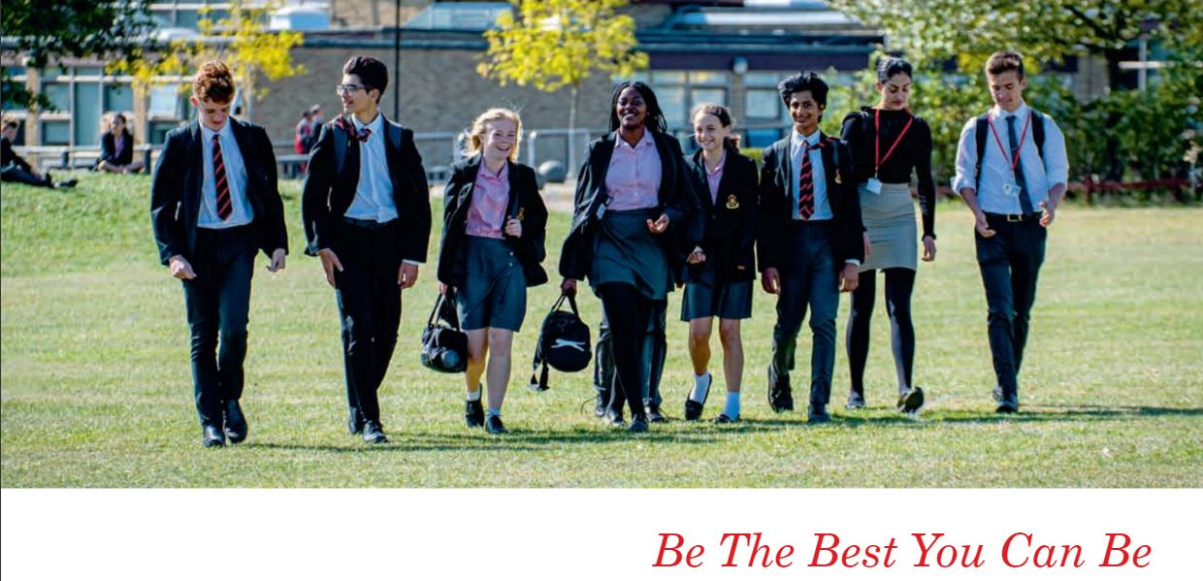

# Pupil premium strategy statement

## This statement details our school’s use of pupil premium (for the 2023 to 2024 academic year) funding to help improve the attainment of our disadvantaged pupils.

## It outlines our three year pupil premium strategy (which has been reviewed from 2022-23), how we intend to spend the funding in this academic year and the effect that last year’s spending of pupil premium had within our school.

## Context- The Local Area

Although the school’s immediate neighbourhood (Local Super Output Area) is ranked 32,350 out of 32,844 areas for Income Deprivation Affecting Children, (making this one of the most affluent areas in the country), there are significant pockets of deprivation within the area. An example of this is the CM13 2B postcode areas which falls into the 4th deprived decile. A proportion of students travel in from Harold Hill, Basildon and Laindon where deciles of deprivation are as high as 20% and 10% of the UKs most deprived neighbourhoods.

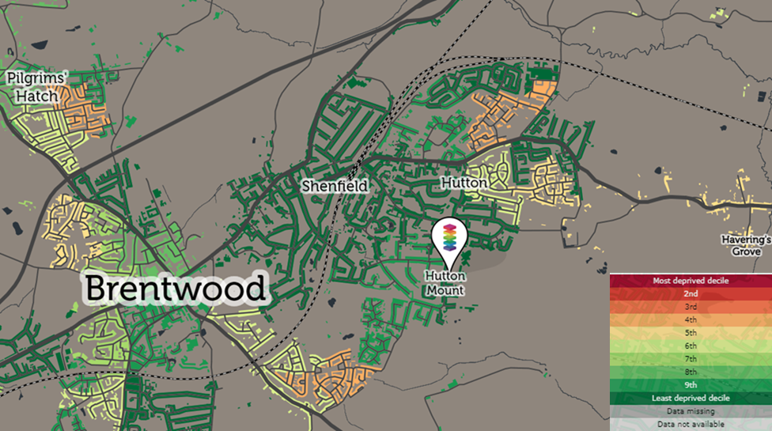

## School overview

|  |  |
| --- | --- |
| Detail | Data |
| School name | St Martin’s School |
| Number of pupils in school | 1859 |
| Proportion (%) of pupil premium eligible pupils | 13% (234 students) |
| Academic year/years that our current pupil premium strategy plan covers | 3 years |
| Date this statement was published | Sept 2023 |
| Date on which it will be reviewed: | July 2024 |
| Statement authorised by | Jamie Foster |
| Pupil premium lead | Sarah Fernandez |
| Governor / Trustee lead | John Bozza |

**Funding overview**

|  |  |
| --- | --- |
| **Detail** | **Amount** |
| Pupil premium funding allocation this academic year | £184,230 |
| Pupil premium funding carried forward from previous years (enter £0 if not applicable) | £0 |
| **Total budget for this academic year** | £184,230 |

**Yr 11 disadvantaged pupil performance overview for 2022/23**

|  |  |
| --- | --- |
| Progress 8 | -0.83 |
| Attainment 8 | 40.48 |
| Percentage of Grade 5+ in English and maths | 18% |
| Percentage of Grade 4+ in English and maths | 32% |

**Disadvantaged KS4 Pupil Performance Over time (Last 3 Years)**

***2021/22***

|  |  |  |  |  |  |
| --- | --- | --- | --- | --- | --- |
| Cohort | Numbers of Students | % Achieving 9-4 En and Ma | % Achieving 9-5 En and Ma | Average Attainment 8 | % Ebacc |
| All | 283 | 98 | 60 | 51.64 | 31 |
| PP | 40 | 58 | 40 | 38.40 | 5 |
| NPP | 243 | 83 | 63 | 53.83 | 31 |

***2020/21***

|  |  |  |  |  |  |
| --- | --- | --- | --- | --- | --- |
| Cohort | Numbers of Students | % Achieving 9-4 En and Ma | % Achieving 9-5 En and Ma | Average Attainment 8 | % Ebacc |
| All | 288 | 87 | 59 | 53.42 | 6 |
| PP | 29 | 72 | 31 | 42.31 | 0.0 |
| NPP | 259 | 88 | 62 | 54.66 | 66 |

***2022/23***

|  |  |  |  |  |  |
| --- | --- | --- | --- | --- | --- |
| Cohort | Numbers of Students | % Achieving 9-4 En and Ma | % Achieving 9-5 En and Ma | Average Attainment 8 | % Ebacc |
| All | 287 | 48 | 75 | 48.96 | 27 |
| PP | 38 | 32 | 18 | 40.48 | 8 |
| NPP | 249 | 81 | 53 | 51.06 | 30 |

# Current Cohorts: Yr 7 Data not available at time of publishing. TBC

|  |  |  |
| --- | --- | --- |
|  | Disadvantaged | Not disadvantaged |
| Average English grade |  |  |
| Average Maths grade |  |  |

## Yr 8 pupil performance Autumn 2023

|  |  |  |
| --- | --- | --- |
|  | Disadvantaged | Not disadvantaged |
| Average English grade | 2- | 2= |
| Average Maths grade | 2= | 3- |

## Yr 9 pupil performance Autumn 2023

|  |  |  |
| --- | --- | --- |
|  | Disadvantaged | Not disadvantaged |
| Average English grade | 2+ | 3- |
| Average Maths grade | 3- | 3+ |

## Yr 10 pupil performance Autumn 2023

|  |  |  |
| --- | --- | --- |
|  | Disadvantaged | Not disadvantaged |
| Average English | 3- | 3+ |
| Average Maths | 3= | 4- |

## Yr 11 pupil performance Autumn 2023

|  |  |  |
| --- | --- | --- |
|  | Disadvantaged | Not disadvantaged |
| Progress 8 | -1.64 | -1.13 |
| Attainment 8 | 31.94 | 54.17 |
| 5+ with English and maths | 9% | 37% |
| 4+ with English and maths | 38% | 67% |

# Part A: Pupil premium strategy plan

## Statement of intent

|  |
| --- |
| Ultimately, we want to help our disadvantaged students to achieve their best possible academic outcomes; including helping close the gap between disadvantaged students and their peers. We are implementing a range of strategies to help achieve this as well as recognising the importance of building the confidence of our students. Whilst we have key objectives to be met in terms of promoting academic achievement it is also important that our disadvantaged students have access to extracurricular interventions to support their well-being, school enjoyment/involvement, sense of self-worth and feeling part of the school community. |

## Challenges

This details the key challenges to achievement that we have identified among our disadvantaged pupils.

|  |  |
| --- | --- |
| Challenge number | Detail of challenge |
| 1 | Poor literacy levels which prevent access to curriculum and poor performance in exams. |
| 2 | Numeracy support- a number of our disadvantaged students have low age-related attainment |
| 3 | Earlier intervention needed at KS3- GCSE students have a wider range of intervention strategies which we need to replicate in lower school if resources allow. |
| 4 | Attendance figures are low amongst some of our disadvantaged cohort which has a direct impact on academic performance. |

## Intended outcomes

This explains the outcomes we are aiming for **by the end of our current strategy plan**, and how we will measure whether they have been achieved.

|  |  |
| --- | --- |
| Intended outcome | Success criteria |
| Improved literacy levels. | Average reading age increasing. Literacy teachers observing a higher attainment level per student. Smaller gap identified between attainment of disadvantaged vs. non-disadvantaged. |
| Improved numeracy levels. | Numeracy teachers observing a higher attainment level per student. Smaller gap identified between attainment of disadvantaged vs. non-disadvantaged. |
| Interventions identified in younger years and possible links to primary feeder schools. | A clear programme which identifies interventions available to KS3 students and evidence of the impact these have had in the form of data. |
| Improvement in attendance figures. | 10% increase in attendance of students who have previously been identified as having low % of attendance. (Those below 85%) |

## Activity in this academic year

This details how we intend to spend our pupil premium (and recovery premium funding) **2023/24** to address the challenges listed above.

### Teaching (for example, CPD, recruitment and retention)

Budgeted cost: £92,095

|  |  |  |
| --- | --- | --- |
| Activity | Evidence that supports this approach | Challenge number(s) addressed |
| Regular staff CPD and curriculum planning to deliver high quality lessons and feedback to students. Staff recruitment of excellent teachers. PP coordinator. Attendance at the Pupil Premium annual conference to keep on top of new information and legislation. | Quality of lessons and teacher feedback has proven to have the most impact on student progress. EEF Toolkit shows an increase in progress of +8 months. | 1, 2, 3. |
| Two teachers given paid Teaching and Learning Responsibility to take on the monitoring of feedback and quality of written communication in students. Key students identified and targeted intervention put in place. | High quality teacher feedback is instrumental in helping our PP learners achieve. EEF Toolkit shows an increase in progress of +8 months. | 1,2,3 |

**Targeted academic support (for example, tutoring, one-to-one support structured interventions)**

Budgeted cost: £70,135

|  |  |  |
| --- | --- | --- |
| Activity | Evidence that supports this approach | Challenge number(s) addressed |
| Small intervention groups, tuition, literacy and numeracy lessons, sixth form peer tuition. Use of Lexia, mymaths, The Brilliant Club etc. to support home learning. | Last year showed an increase in performance from those receiving tuition- on average a sub grade higher than their peers.  The use of digital technology to support learning has been identified by the Sutton Trust as having a 4 month increase in progress. | 1,2,3 |

**Wider strategies (for example, related to attendance, behaviour, wellbeing)**

Budgeted cost: £22,000

|  |  |  |
| --- | --- | --- |
| Activity | Evidence that supports this approach | Challenge number(s) addressed |
| Supporting extracurricular activities to improve attendance, self-confidence and organisation/punctuality. This includes: trips, music tuition, uniform, etc. | The commitment to practice and organisational skills acquired are also skills that can be applied with their school studies. EEF Toolkit shows an increase of +2 months progress. | 4 |

**Total budgeted cost: £** 184,230

# Part B: Review of outcomes in the previous academic year 2022-23

This details the impact that our pupil premium activity had on pupils in the 2022 to 2023 academic year.

|  |
| --- |
| **Yr7:** Disadvantaged students (DS) started on an average 1+ in English which was in line with their disadvantaged peers (ND) also at 1+. By the summer term DS had made one sub grade improvement to 2- and ND students had made slightly more same progress to 2=. Whilst it is pleasing that they have remained in the same grade banding it highlights the need to ensure that we do not allow this gap to widen. In maths DS started the year at 2- and ND were two sub grades ahead at 2+. The gap remained at two sub grades with each sub group moving a sub grade. 2= (DS) and 3- (ND). Whilst it is pleasing that our disadvantaged students have worked at the same pace as our ND they do need to make significantly more progress in order to catch up.  **Yr8:** Disadvantaged students started the year at 2= in English and 2+ in maths with their ND peers starting a sub grade higher at 2+ and 3- respectively. In a similar trend to Yr7, maths saw a higher end grade of 3- for DS compared to 2+ in English. Although students made steady progression this still puts them a sub grade behind ND students in both maths and English. Small group intervention sessions have been put in place to try and stop this gap from widening.  **Yr9:** DS in English started the year on an average grade of 2+ and finished the year at 3-. In comparison NDS started at 3- and progressed to 3+. The ND have progressed at a higher rate than their disadvantaged peers and this will need to be tracked in Yr10 and interventions put in place to allow DS to catch up. In maths DS students went from 3- to 3+ and NDS ended the year a sub grade higher at 4-. The main focus for Yr9 into 10 will be to try and keep them progressing at the same rate as their peers so as to avoid falling further behind.  **Yr10:** Our English DS started their GCSE course in English working at a 3= and finished the year at the same level. Students for small group interventions have been identified for next academic year to help them close the gap. A similar picture is seen in maths where DS started at 3+ and ended also at 3+. Their ND peers however started at 4- in English, 4= in maths and have progressed to 4+ and 5- respectively. Interventions will be put in place in the early Autumn term and the PPE results in December will be a clear indicator of whether the gap is closing.  **Yr11:** Despite our DS having an initial working at grade of 58% 9-4 EM, they went on to achieve a much lower percentage. Their Estimated End Grades (EEG) were 45% and again the actual result was significantly lower at 32%. This was a weaker cohort than previous years and progress 8 was a sight improvement on last year but we definitely need to ensure our data accurately reflects their abilities to ensure intervention is put in the right place. |

## Externally provided programmes

|  |  |
| --- | --- |
| Programme | Provider |
| Lexia PowerUp | Lexia |
| The Brilliant Club | Young Scholars |
| Book Buzz | The Book Trust |
| Mymaths | Oxford University Press (due to be phased out 2023-24 |
| Exampro | AQA |
| Sparx Maths | Sparx |

## Service pupil premium funding (optional)

*For schools that receive this funding, you may wish to provide the following information:*

|  |  |
| --- | --- |
| Measure | Details |
| How did you spend your service pupil premium allocation last academic year? | n/a |
| What was the impact of that spending on service pupil premium eligible pupils? | n/a |